Lesson 10

Demo 10: How to Push a Docker Image on Docker Hub

Code_01: app.py
from flask import Flask
import os
import socketapp = Flask(__name__)@app.route(“/”)def hello():
html = “<h3>Hello {name}!</h3>” \
“<b>Hostname:</b> {hostname}<br/>”
return html.format(name=os.getenv(“NAME”, “world”), hostname=socket.gethostname()) if __name__ == “__main__”:
app.run(host=’0.0.0.0', port=80)
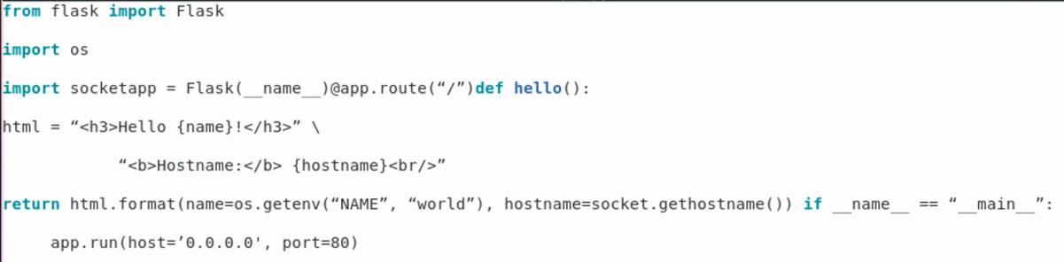

Code_02: Dockerfile
FROM python
WORKDIR /app
ADD . /app
RUN pip install -r requirements.txt
EXPOSE 80
ENV NAME world
CMD [“python”, “app.py”]

